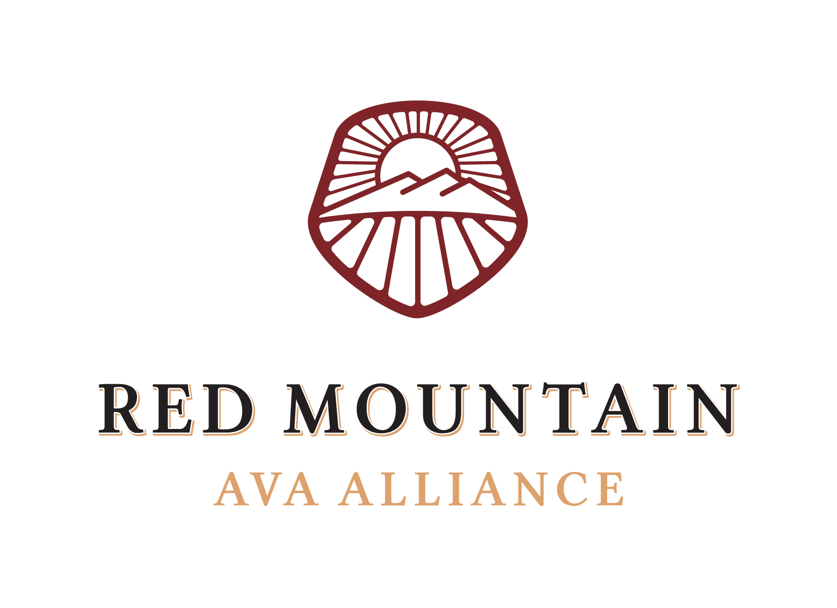

Board Meeting Minutes

August 12th, 2021

- Call to Order at 8:07am

- Attendance & Introductions

- Directors & Staff present:
- Kristin Adams
- Alicia Brown
- Maggie Hedges
- Tim Hightower
- Will Hoppes
- Karla Riccobuono
- Mandy Walters
- Mellissa Whitaker

Directors & Staff NOT present:
- Even Johansen
- April Reddout

- Members & Sponsors present:
- Cam Matches, Aquilini

- Guests present:
- Kayt Mathers, Play Nice PR

- July Meeting Minutes & Board Retreat Minutes – approved unanimously.

- Financial Report – reviewed by Treasurer, Kristin Adams. The following items were noted:
- The Alliance received $4,812.23 from the US Treasury that serves as an Employee Retention Credit for 2022.
- Expenses were incurred in July for Taste Red Mountain prior to postponing the event; refunds will show in future reports.
- The money market account is now accurately named.
- July’s monthly retainer for PR was paid in August and will show on later reports.
- Payments on the following items will come in August: Andrea Johnson photoshoots, Facebook advertising for Taste Red Mountain, Washington Wine Institute dues, Board Retreat lunches and insurance.

- Digital Report – reviewed by Mellissa Whitaker. In addition, the board discussed including harvest social media information in the next edition of The Dirt on Red Mountain. Alicia will work with Play Nice PR to encourage members in sharing harvest imagery on social media using the hashtags #harvest2021 and #redmtn, while still being cognizant of imagery that could create condemnation or backlash for the region.

- Ongoing Business

- I-82 Sign Update – Alicia Brown reported that the Alliance is waiting to receive the completed application from WSDOT; after receipt, the application will need to be signed and returned for work to start. Information on how to submit payment will be provided in the application.

- SR 224 Sign Update – Maggie Hedges provided an update on construction of the SR 224 sign, which is expected to be complete soon. Maggie also announced that the font the board voted on, Trajan Pro, is too thin to be custom cut for the sign. Christophe is now recommending the board to use Times New Roman as the font for the sign.
- Vote on proposed font – unanimously approved the use of Times New Roman.

- Ongoing Business, cont.

- Debrief Taste Red Mountain – Alicia Brown provided a debrief on the postponed event including an overview on the following items:
- Ticket refunds/ holds – 108 tickets were originally sold; 50 tickets have been refunded thus far.
- Vendor refunds – the Alliance will receive $2,085 in refunds from event vendors.
- Feedback – Alicia provided feedback from members, sponsors and vendors.

- Update from Play Nice Public Relations – Kayt Mathers reported on media invited to attend Taste Red Mountain; Kayt noted that multiple media including Paul Gregutt have noted they would be interested in visiting in the future. Kayt recommending hosting a media fam tour in May 2022. Additionally, Joe Micaleff, a writer from Forbes, decided to keep his travels and have one-on-one appointments on Red Mountain on August 8.

Kayt also announced images from Andrea Johnson are now available for members to use on social media; Alicia will send information on how to utilize images, as well as a reminder of how to use Kim Fetrow’s images, to members.

The board agreed to change dates of the 5 Pillars of Red Mountain Virtual Series to Tuesdays, beginning on October 19th in order to accommodate Julia Coney being the moderator.

- Advertising & Promotion Budget Update – Will Hoppes reported that the Hype Committee met and determined additional funds left in the Advertising & Promotion Budget. The board recommended using additional funds to extend the PR contract by one month and host two media writers by the end of 2021. The board also agreed that it will be important to start the PR contract in February 2022 in order to prepare for a spring media fam tour.

- Members-only website page – Alicia Brown reported that she will be working on a members resource page during harvest which will house important information such as the bylaws, meeting agendas and minutes. Additionally, the page will have a password protected link to access Alliance image available to members. The board recommended using Dropbox to organize images.

- Zoning Update for farm-stand variance – Alicia Brown announced that we have received an application from Benton County to update zoning. Alicia noted that while the board agreed to update the zoning, it was not specified who would submit the application. The board unanimously agreed for the Executive Committee to discuss further and determine the best method of moving forward.

- New Business

- 5 Pillars of Red Mountain Virtual Series – Maggie Hedges announced that a request was sent to members to participate in the series. She also noted that the Events & Infrastructure Committee will meet on Tuesday, August 17th to further plan the series.

- Member Meet & Greet / Board Social – Maggie Hedges noted local member wineries not affiliated with board members include Hamilton Cellars, Muret-Gaston Winery, Market Vineyards, Pacific Rim and Schooler Nolan. Maggie recommended hosting member meet & greets at Hamilton, Muret-Gaston, Market and Pacific Rim in 2022 and hosting a board social at Fat Olives in 2021. The board decided to host the host social on December 9th.

- Regional Association Roundtable Meeting – Alicia Brown provided information presented at the Regional Association Roundtable meeting. Alicia noted opportunities for wineries and vineyards that she will include in The Dirt on Red Mountain. Additionally, Alicia reported that she is working with Bretty at the Washington Wine Commission to create a road trip itinerary of all Red Mountain AVA Alliance members for the new app.

- Questions/Comments – no questions or comments.

Prior to adjourning, Maggie Hedges motioned to extend the PR contract with Play Nice Public Relations by one month to end in November. Kristin Adams seconded the motion and the motion passed unanimously.

- Adjourn – at 9:26am

