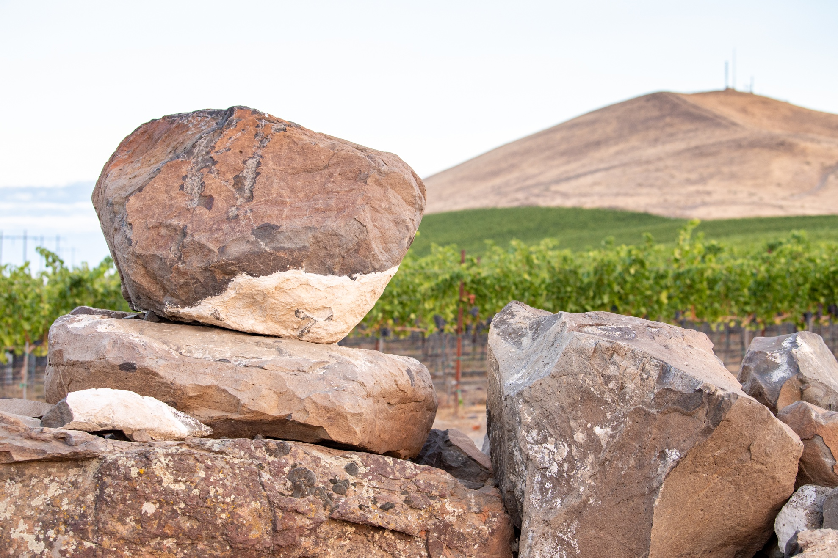
Red Mountain AVA Alliance
Organization Information
& Partner Benefits
2023

Vision

To have the Red Mountain AVA be recognized as one of the great wine growing regions of the world.

Mission

To increase the demand for Red Mountain AVA fruit and wines by cultivating awareness and enhancing the reputation of the region with trade, media, and consumers.

Methods & Objectives

- Build value for members
- Outreach to media & trade
- Expand social media and online presence
- Curate digital resources for members
- Enhance visitor experiences and opportunities
- Grow relationships with other trade organizations, collaborate when appropriate
- Communicate clearly and consistently with members

2023 Committees & Goals

The Hype Committee will:
- Resource & guide hired PR firm, Play Nice Public Relations to:
  - reach regional and national wine & lifestyle publications
  - cultivate media opportunities in influential wine & lifestyle publications
  - provide opportunities for trade and media to connect with Alliance members and to learn about the Red Mountain AVA and its wines
- Target specific wine writers to visit Red Mountain with custom itineraries and to write about Red Mountain
- Continue development of digital strategies, storylines and messaging on Instagram, Facebook and redmountainava.com with the goal of:
  - expanding mailing database (GOAL: 2,200 by Dec. 31, 2023)
  - expanding Instagram following (GOAL: 3,375 total followers by Dec. 31, 2023)
- Create annual campaign calendar for Facebook & Instagram and encourage members to participate
  - create duty schedule for Hype Committee to post
  - create dropbox for members to share pictures
  - post articles to Facebook & Instagram
  - encourage members to like, save, share & comment on every @redmtnava post
  - host social media bootcamp for members
- Lead marketing efforts for Alliance hosted events and promotion of other Alliance projects including map, fact sheet, Five Pillars document, etc.
- Create quarterly consumer-facing e-newsletter
- Refresh AVA Press Kit, including AVA Fact Sheet
Committee Chair: Will Hoppes, will@fidelitaswines.com

The Events & Infrastructure Committee will:
- Plan & execute two to three Taste Red Mountain events in 2023:
  - (consumer event) Red Mountain
  - (consumer/trade event) Woodinville
- Explore event opportunities in Spokane and other locations
- Plan & execute educational member event with Kevin Pogue
- Explore further into visitor experience projects such as vineyard row signage, sidewalks and vineyard trails (efforts by the City of West Richland through the SR 224/ Red Mountain Transportation Improvement Project, Badger Mountain Trails proposed Red Mountain Vineyard Trail, and Benton City’s pedestrian bridge)
- Partner with neighboring government organizations such as the West Richland Planning Commission and the Benton City Revitalization Organization on projects relating to the Red Mountain AVA, when necessary
Committee Co-chairs: Karla Riccobuono, karla@hedgesfamilyestate.com & Maggie Hedges, maggie@domainemagdalena.com

The Partner Relations Committee will:
- Retain existing members & sponsors
- Solicit new members & sponsors, increasing small winery memberships
- Engage existing members & sponsors
- Survey stakeholders annually for feedback and present results at April Board Meeting (prior to May/June Board Retreat)
- Regularly review member/sponsor benefits & dues and provide initial recommendations at April Board Meeting (prior to May/June Board Retreat)
- Plan & execute sponsor giveback program
- Plan & execute quarterly member socials
- Develop and grow relationships with other trade organizations including the Washington Wine Commission, Washington Wine Institute, Winegrape Growers of America, Tri-Cities Wine Tourism Council, etc.
- Create and send The Dirt on Red Mountain on the third Thursday of each month
- Source and refresh digital resources available at redmountainava.com/member-resources including:
  - AVA Map (printed & distributed to members at Taste Washington
  - RMAVAA Image Gallery
  - Five Pillars of Red Mountain document
- Communicate digital resources available to members & educate members on how to use them
Committee Chair: Jen Porter, jennifer.porter@colsolare.com

The Executive Committee will:
- Oversee Alliance business affairs/operations in a fair and efficient manner
- Work collaboratively with board members and staff to ensure organizational goals are mission-centered, communicating updates to members and sponsors, ensuring annual updates are made to the RMAVAA Organizational Information & Partner Benefits Packet
- Guide and direct staff
- Act as liaison between paid staff and board/membership
- Ensure board members adhere to board roles and responsibilities
- Plan & execute RMAVAA monthly board meetings, Annual Meeting and annual Board Retreat
- Ensure annual board elections take place at the Annual Meeting
Committee Chair: Maggie Hedges, President, maggie@domainemagdalena.com
This committee is made up of the President (Maggie Hedges), the Vice President (Will Hoppes), the Treasurer (Kristin Adams) and the Secretary (Karla Riccobuono).

2023 Calendar of Events

Second Thursday of Each Month (excluding Sept & Oct) – Board of Directors Meeting
at 9:00am at Hedges Family Estate or virtually on Zoom
Third Thursday of Every Month – The Dirt on Red Mountain e-newsletter published
February, May, August, November – A Note from Red Mountain published

January
19: Member Social

February– October
Play Nice Public Relations on retainer

February
16: Social Media and 2023 PR Plan Member Meeting (Zoom)
16: Ticket Sales Open for Taste RM Woodinville
24: Membership payment deadline to be included in AVA maps

March
1: (tentative) Ticket Sales Open for Taste RM
8: Final day to submit interest in running for board positions
11-12: RMAVAA hosts table at Taste Washington (AVA maps printed & delivered to members in attendance)
16: Stakeholder Feedback Survey included in The Dirt
20: Board of Directors Ballots sent to members

April
7: Stakeholder Feedback Survey Due
7: Final day to submit board ballots
13: Annual Meeting (Board election results announced)
22: Taste RM Woodinville
22: Member Social (westside)
25: Kevin Pogue Geology Presentation

May
4: Board Retreat

June
8: Member Social
9-11: Taste Red Mountain weekend
- Collaborative dinners
- Grand Tasting
- Yoga
- Guided Vineyard Hike

July

August
Member/Sponsor renewals begin
24: Member Social

September
(Board of Directors break for harvest; no monthly board meeting hosted)

October
(Board of Directors break for harvest; no monthly board meeting hosted)

November
9: Draft Budget presented at monthly Board Meeting

December
7: Member Social (westside & RM)
14: 2024 Final Draft Budget presented at monthly Board Meeting

2022-2023 Board Members

Maggie Hedges, Domaine Magdalena, President

Will Hoppes, Fidélitas, Vice President
Karla Riccobuono, Hedges Family Estate, Secretary
Kristin Adams, Upchurch Vineyard, Treasurer
Jason Gorski, DeLille Cellars
Richard Holmes, Ciel du Cheval/ Côtes de Ciel
Cameron James, Tinte Cellars
Teresa Owen, Red Mountain Trails Winery
Jen Porter, Col Solare

Staff

Executive Director – Alicia Brown

alicia@redmountainava.com

Memberships & Sponsorships

Red Mountain AVA Alliance projects listed in this document would not be possible without the support of our annual members and sponsor. Please consider joining us in our efforts through an annual membership and/or sponsorship with the Red Mountain AVA Alliance.

For information on membership/sponsorship dues, please see the subsequent pages. Contact Alicia Brown, Executive Director at alicia@redmountainava.com or by phone at 509-521-8863 for more information and to sign up.

2023 Winery/Vineyard Membership Dues Calculator

There are three Red Mountain AVA Alliance membership types:
- Grower-Only: Farming grapes, selling fruit, not producing finished wine.
- Winery: Producing Red Mountain AVA designated wine whether from fruit you farm in the AVA or purchased from another Red Mountain AVA vineyard, no Red Mountain tasting room.
- Estate Winery & Tasting Room: Producing Red Mountain designated wine AND operating a tasting room within the AVA.

Please complete one section below for your appropriate membership type.

GROWER-ONLY
Enter total number of Red Mountain AVA vineyard acres farmed on the appropriate line.
Base Membership Fee |  |  |  |  | $300
Up to 10 acres |  | X | $80
 |  |  |  |  | +
Between 10 and 150 acres |  | X | $40
Over 150 acres |  | X | $20
 |  |  | TOTAL | =
 |  |  |  |  | $3000 maximum

WINERY
Calculate average annual case production using your three most recently bottled vintages, enter on the appropriate line.
Use Red Mountain AVA designated wines only.
Base Membership Fee |  |  |  |  | $400
Up to 1,000 cases |  | X | $0.60
 |  |  |  |  | +
Between 1,001 and 7,000 cases |  | X | $0.45
Over 7,000 cases |  | X | $0.35
 |  |  | TOTAL | =
 |  |  |  |  | $4000 maximum

ESTATE WINERY & TASTING ROOM
If you operate a tasting room in the Red Mountain AVA, complete this section.
Calculate average annual case production using your three most recently bottled vintages, enter on the appropriate line.
Use Red Mountain AVA designated wines only.
Base Membership Fee |  |  |  |  | $600
Up to 1,000 cases |  | X | $0.60
 |  |  |  |  | +
Between 1,001 and 7,000 cases |  | X | $0.45
Over 7,000 cases |  | X | $0.35
 |  |  | TOTAL | =
 |  |  |  |  | $4000 maximum
2023 Sponsorship Opportunities & Benefits

Friends of Red Mountain: $300

Friends of Red Mountain sponsors receive the following benefits:
- Listing on redmountainava.com with hyperlink to sponsor website
- Invitation to attend monthly RMAVAA Board Meetings & Annual Meeting in Spring
- Invitation to join in committee efforts
- Subscription to RMAVAA monthly industry e-newsletter, The Dirt on Red Mountain, and Red Mountain AVA’s quarterly consumer-facing e-newsletter, A Note from Red Mountain
- Winery/vineyard general contact information
- First right of refusal for event specific & other sponsorships

Sustaining Sponsor: $1,000

Sustaining sponsors receive all Friends of Red Mountain sponsor benefits plus:
- Listing on redmountainava.com with hyperlink to sponsor website with logo
- Listing on marketing materials for Alliance hosted events
- Complimentary invitation to select Alliance hosted events

Leadership Sponsor: $3,000

Leadership sponsors receive all Sustaining sponsor benefits plus:
- Recognition on monthly industry e-newsletter, The Dirt on Red Mountain, and Red Mountain AVA’s quarterly consumer-facing e-newsletter, A Note from Red Mountain
- Invitation to be a guest speaker at one RMAVAA Board Meeting annually
- Two tickets to attend a Taste Red Mountain Grand Tasting (Woodinville OR Red Mountain)

Premier Sponsor: $10,000

Premier sponsors receive all Leadership sponsor benefits plus:
- Listing on redmountainava.com with logo, description of services and link to direct contact
- Sponsor-generated industry-related content included in RMAVAA monthly industry e-newsletter, The Dirt on Red Mountain, and/or sponsor-generated content included in Red Mountain AVA’s quarterly consumer-facing e-newsletter, A Note from Red Mountain
- Winery/vineyard list with direct contact information
- Two cases of mixed wine from Red Mountain AVA members

