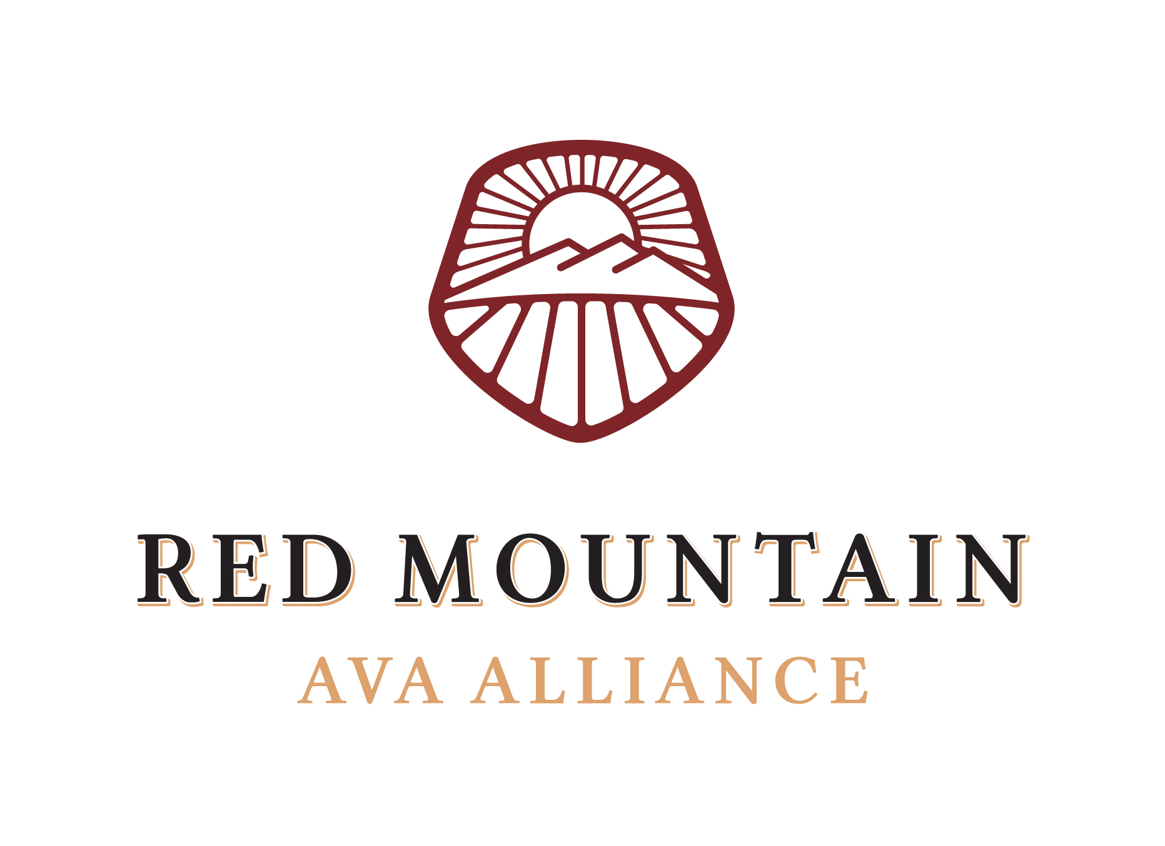

Board Meeting Minutes

July 14th, 2022

- Call to Order at 9:06 am

- Attendance & Introductions

- Directors & Staff:
    - Kristin Adams - present
    - Alicia Brown – NOT present
    - Jason Gorski – NOT present
    - Maggie Hedges - present
    - Richard Holmes - present
    - Will Hoppes - present
    - Teresa Owen - present
    - Jen Porter - present
    - Karla Riccobuono - present
    - Mandy Walters – NOT present

- Members & Sponsors:
i. Cameron James, Tinte

- Guests:
i. Kayt Mathers, Play Nice Public Relations
ii. Kelsey Hutchinson, Play Nice Public Relations
iii. Sarah Funk, Benton City Councilwoman
iv. Linda Lehman, Benton City Mayor
v. Jeff Von Schmauder, local resident, and Benton City Developer

- Sarah Funk gave the board an update on the Benton City Rails to Trails Project, which puts a park along the river and a pedestrian/bike bridge on the Union Pacific abandoned railway bridge across the Yakima River. The end goal is to connect approximately 70 miles of regional trail systems to enhance rural, economic vitality and attract recreation tourism from around the region and the world. They also hope to close the 7-mile gap in the Tapteal Greenway over a land trail between Horn Rapids Park and Hope Lane in Benton City. They received a 2 million Federal appropriation by Dan Newhouse, and now are awaiting the bill to go through Congress before receiving the funds. Ideally, the funding would begin in 2023. Important to note that the appropriated money all goes to the bridge restoration project. Trails would be separate funding. Knowing the Federal money is coming might be helpful to Friends of Badger Mountain’s efforts for the AVA trail in getting the last of the land rights approved.

- Mayor Linda Lehman gave the board a presentation on the sub-plan area for the DNR plan off I-82 near the Shell Gas Station, SE of the roundabout. The parcel is about 238 acres, mostly DNR and BLM land. Mayor Lehman reported that they had just had a committee planning meeting on Monday & Tuesday prior to the board meeting so she was unable to load the packet documents online or give them to the board for electronic viewing. In person, the board received a packet showing 3 different architectural and design plans for the sub-plan area, noting that an “iconic structure” e.g., an upscale hotel with a restaurant, ideally would be the focal point and what anyone would see driving. The proposed plans will soon be added to the city’s website and there is also a community survey being circulated to obtain feedback from local stakeholders on the development of this area. A link to the survey and the city’s informational website will be included in the next edition of The Dirt. The land is slated for light industrial, commercial, multi-family, and residential, with a greenbelt. The industrial zoning would be closest to the freeway to drown out the noise. The plans were created with a European Village in mind, to have a town center, be walkable, and have amenities available within the community. DNR will sell the residential land but will do ground leases for commercial and industrial lots. This will now be put into a comprehensive plan to send to the County, which then will hopefully get grants and funds, and seek a developer.

- Jeff Von Schmauder is seeking a partnership and support from the AVA to develop a tasting room/wine bar/event space in Benton City that would be Red Mountain wine-focused. He was seeking a discussion on how to go about this, and what this would look like, and wants to be a resource for the AVA. Jeff wants to collaborate with Marc Newman of Wine Social to run the space which would serve as a “concierge” and help set up tours, tastings, etc. The board was overwhelmingly supportive of the idea in general however in no partnership-affiliated way and recommended that he reach out to wineries individually.

- Approval of June Meeting Minutes – The June Meeting Minutes were approved unanimously as presented. Maggie noted that the board can approve the minutes electronically when the draft is sent out by email.

- Financial Report – Kristin presented the Financial Report as of June 30th. The Alliance currently has $76,312.89 cash on hand and has spent 49% of the annual budget ($61,751.13 of $125,000.54). Maggie noted that there were a few lingering expenses that might come through post-Taste Red Mountain since the photographer had not picked up her check yet. Alicia took sick pay which is why there are wages for the Executive Director, it is not paid maternity leave.

- Digital Report – Will reported that Alicia’s scheduled Instagram and Facebook posts were still happening, and he goes in to post the hashtags on each. The Instagram account currently has 2,583 followers. Will reported a spike in Facebook likes after good traction from the podcast Maggie was featured on. The hype team is going to focus on putting more info on Facebook and noted that faces and features on people do best. Maggie asked that we use the pictures from Taste Red Mountain and spotlight each member now that we have the photos from the photographer, and the photos will be added to the resource page on the website.

- Play Nice Public Relations Update –Kayt included recent press and media coverage post-Taste Red Mountain. Kelsey attended and gave positive feedback that the event was a good size, well received, was a good setup, and noted that the media were able to get great facetime with the winemakers. As a result, we have seen eight pieces in coverage in Great Northwest Wine, Washington State Wine Commission, KNDO/KNDU, iHeartRadio, Northwest Public Broadcasting, This Way with Tay, and Local Wine Events. Coverage included three podcast interviews, television, calendar event listings, written social media, and influencer posts. In total, coverage of Taste Red Mountain was seen by an estimated 11.7 million unique monthly visitors.

Kelsey gave a June Digital Recap and reported that 2 sets of ads were launched on Facebook. One, targeting new audiences who look like the current engaged Red Mountain audience driving clicks to the about Red Mtn web page, and a second one targeting existing audiences driving traffic to the Plan Your Visit page. She reported that in the keyword strategy for SEO, Red Mountain is performing well in the expected key phrases however it should rank higher for others, for example, WA Wine. This is where google ads come in and help catapult Red Mountain to the top of these searches. She also mentioned that members/wineries adding these key phrases to their own website, and a link to the Red Mountain AVA website would help with SEO.

Kayt asked about info or new things that Play Nice needs to be aware of for adding to The Dirt and mentioned that they are including the winery bios (not a lot of responses for updates, so bios are staying as is), USA 10 Best Voting, WA Wine month of August, events or specials for the holidays, update on the Horse Heaven Hills wind farm project, that Sip Magazine, Best of NW and Wine Enthusiast have a new reviewer and expectations for Harvest. In response to Kayt’s question, Richard mentioned Merlot Me Month, and that he hopes to have a tasting room next year. Maggie updated that DMag’s tasting room is looking to open later this year as well. There was also discussion about 40 acres that recently received water rights and will likely be planted soon, as well as the Frichette’s new lot.

- Ongoing Business and New Business were postponed to next month’s board meeting due to the length and overtime of this meeting. Alicia will return in August, and the board will recap with each committee then to provide updates and discuss future planning meetings before taking a break for September and October.

- Adjourn at 10:58 am.

