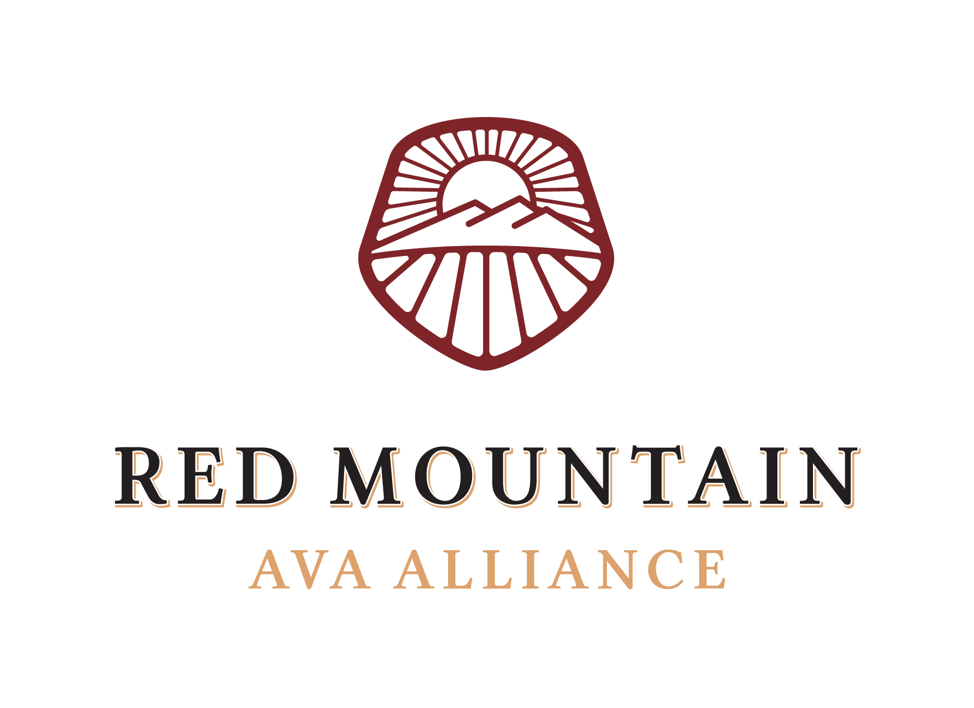

Board Meeting Agenda

December 8th, 2022

- Call to Order 9:02 AM

- Attendance

- Directors: Kristin Adams, Jason Gorski, Cameron James, Maggie Hedges, Richard Holmes, Teresa Owen, Jen Porter, Karla Riccobuono

- Executive Director Alicia Brown

- Members & Sponsors: Megan Hughes from Barnard Griffin

- Guests: Kayt Mathers, Play Nice Public Relations; Vanessa Hadick, Double Tap Marketing

- Not in Attendance: Will Hoppes

- Operations Reports

- Financial – Kristin reported that as of November 30th, 2022, the Alliance has $43, 574.50 on hand and has spent $104, 984.02 of $125,000.54, 83% of the annual budget. Dues are still being collected and the Alliance should anticipate starting 2023 with approximately $30-35K. Expenses in December will be minimal and due to Alicia being on maternity leave this past year, the Alliance saved on that part of the budget. Kristin also noted that every time a member pays with quick books, a fee is incurred and needs to be incorporated into the budget.

- Digital – Alicia reported that the Red Mountain AVA Instagram account as of December 6th, 2022, has 2,894 followers (an increase of 16). The goal of 2,800 by December has been exceeded largely because of how popular the giveaway posts were. Followers' increase slowed down in December. The highest-reaching post and the most liked post were the giveaways. Alicia is looking for more ideas for new giveaways and will reach out to members directly. A note in The Dirt will be added again. The Facebook page has 1,916 followers, and 1,746 likes (an increase of 2 and 3, respectively).

- Digital Advertising – Vanessa reported an overall advertising and digital recap of 2022. Key updates and implementations of google analytics to understand consumer behaviors. The efforts focused on the visit and the vineyard pages on the AVA website to enhance engagement. Advertising efforts focused on Google, Facebook, and Instagram. Growth in website visitors was about 1200 per month. Organic growth overall was generated mostly by google searches or by key terms. Call to Action buttons had the highest click-through rates and strongest engagement. Vanessa also noted that trends in Oregon this time of year dictate that traffic typically dies down digitally however that has not shown to be the case for Red Mountain. This is due to the website having valuable content and the paid ads which have driven overall growth. $1041 total was spent on ads which resulted in over 262K impressions. Vanessa's key recommendations to increase growth are to offer something of value to consumers in absence of events such as cellaring guide, vintage overviews, and maps, also a continual improvement on SEO, calls-to-action, website content, long-form content, and finally, that consumer engagement is strongest in lead up to events. Alicia will add the statistics recap to the end-of-year wrap-up and will link to the report on the website and in member communication. The board agreed that continuing with Double Tap is not in the budget for next year however it was a very valuable partnership with a lot of great tips to build on for the future. Alicia will take over and continue with digital ads around events and Taste Red Mountain.

- Public Relations – Kayt provided a 2022 recap to the board and presented the plan for Play Nice’s activities for 2023. Kayt included in the packet the top press and articles from 2022 and will provide us with the full Decanter Magazine article later since it requires a subscription to read. Play Nice will target top wine writers to visit Red Mountain as individuals, targets are Samantha Cole-Johnson of Jancis Robinson, Owen Bargreen of Vinous, and Michael Alberty of Wine Enthusiast. Kristin noted that Owen Bargreen left vinous a few months ago, at the time, Kayt was unaware of this and will recommend a replacement. Play Nice will create an outreach strategy around top wine reviewers such as Anthony Mueller of Robert Parker/Wine Advocate, James Suckling, and Tim Fish of Wine Spectator. Play Nice will continue to support the TRM events in Woodinville and Benton City by securing media opportunities to bolster ticket sales and invite top regional media to attend as well as provide PR support. Play Nice will also host an in-region FAM tour if the budget allows, targets include Brian Friedman of Food & Wine and Lauren Mowery of Forbes. Play Nice would also partner with Visit Tri-Cities to host in-region travel writers. Play Nice would like to host another brainstorming session with more targeted questions with the AVA members in the spring. Play Nice’s monthly retainer has increased, and the contract is suggested to now be a 9-month contract rather than a 10-month for the Alliance to keep the cost the same. This does not include expenses, which Kristin noted can vary drastically and the Alliance should be careful about. The board agreed that there should be a clearer understanding of what is included in the retainer price and should be evaluating any expenses before they are incurred. It was also agreed upon that the board would like more marketing efforts from Play Nice however they are a PR firm and looking at the Alliance for marketing direction. The board needs to reevaluate the value of Play Nice and look at adding a focus on marketing strategies and vision. The board agreed to have a separate meeting in January to discuss a broader marketing focus, vision, strategies, and press to which the Hype Committee can do the groundwork.

Alicia has been in touch with the WA Wine commission about partnering and essentially was told this was not an option. Members that have relationships with the WA Wine Commission and media should reach out directly rather than the Alliance as a liaison.

Advertorials such as Taylored Living sponsored promo (about 5K/year) potentially will be a buy-in cost from members. It was noted that any new advertorial opportunities would require editorial efforts in writing and in photos, which provides a lot of opportunities for options.

- Ongoing Business

- Committee Updates & Budget Requests
- Executive – Maggie reported that the Executive Committee met to finalize the cost-of-living increase for Alicia and to discuss a performance review. The Committee approved a 4% increase for 2023 to finalize the budget. In reviewing the previous job description and duties, the Committee realized that it is out of date and wants to update it first in order to give an accurate performance review with Alicia. Once the description is updated, the Committee will provide Alicia with feedback and will change the employee review to the month of August before the board’s break for harvest which then allows the budget to be finalized upon return.
- Events & Infrastructure – Maggie reported that the Events Committee is planning a date change to TRM-West to April 22nd since Taste WA is back in March. TRM-East will not include a run as originally planned due to scheduling conflicts with Runners of the Sage and surrounding dates. The committee would like to offer a guided hike along the RM trail and is also pursuing conversations with local yoga studios/instructors to offer a morning class. Teresa added that she attended an open house meeting that discussed the Van Giesen expansion project for the walking/running trail up to Antinori which is scheduled to begin in 2023. The project is planned for the opposite side of Van Giesen/224 than the RM sign is on. An idea was discussed about the possibility of adding a crosswalk or light in hopes of connecting the trail to Antinori or the sign.
- Hype – Alicia reported that the Hype committee met to plan out the next year and would like to have monthly meetings with Play Nice. They are working on a campaign calendar for social media posts and planning.
- Partner Relations – Jen reported that there have been 11 renewals and 4 commitments from new members. The estimated income is about 16K with more to come next month. Currently, the committee is meeting twice per month. Neil Cooper talked to Maggie at the Hedges industry party and Maggie will follow up directly with him in person regarding possible membership.

- The 2023 Draft Budget was looked over and ultimately the board was waiting for a final vote until Will could look at the marketing line, however, Kristin and Richard suggested that we proceed with a vote on the bottom-line numbers. Maggie wants all board members’ opinions on the bottom line since the Alliance budget operates at a deficit. There is a need to have a small amount of savings in the bank to cover the basic operations. However, the budget operating at a deficit takes a third of the Alliance's overall savings. The consensus among the entire board was that there was optimism for increased memberships, and everyone was comfortable passing the budget at a deficit. For the future, there needs to be a strategy for closing the gap, adding new memberships, increasing sponsorships, and possibly having members increasingly subsidize events as well as charge more for tickets to events. Having an updated list of benefits of being a member of the AVA that is accessible to all members as well as links to press will help. There was a mistake in the line item regarding Play Nice’s contract which added 1K back to the budget. The line item for Media Tours was changed to Media Tours and Advertising Campaigns. Maggie motioned to vote to approve the current draft budget, changing the PR budget to $22,500, Media Tour changed to Media Tours and Advertising, which changed projected income to $100,425.00, projected expenses to $108, 680.46 and a deficit of $8,255.46; Kristin seconded, and it passed unanimously.

- Questions/Comments- none

- Adjourn at 10:30 AM

The next meeting of the Red Mountain AVA Alliance will be held on

Thursday, January 12th, 2023, at 9:00 am at Hedges Family Estate

